PROJECT REPORT
DELHI AIR QUALITY INDEX (AQI) ANALYSIS
Shadowfox – Intermediate Data Analysis Task
Python • Pandas • NumPy • Matplotlib • Seaborn • Jupyter Notebook
Prepared from the submitted Jupyter Notebook and README

1. Project Overview
This project is an intermediate-level data analysis and visualization task focused on Delhi air-quality data. The notebook loads the dataset with Pandas, prepares the date and pollutant fields, estimates an AQI value using a weighted formula, and visualizes the results through monthly analysis, an AQI distribution plot, weekday box plots, and a pollutant/AQI correlation heatmap.
The submitted README describes the project as an intermediate data-analysis and visualization exercise intended to clean, process, and represent data through meaningful visual insights. It specifically lists Pandas for data handling and Matplotlib for visual reporting, with NumPy noted for numerical operations if used.

2. Objective
- Perform data analysis using Pandas.
- Create visual reports from the air-quality data.
- Identify trends, patterns, and relationships in the dataset.
- Study estimated AQI variation across months and weekdays.
- Examine relationships between AQI and pollutant variables.

3. Tools and Libraries
Library/Tool | Purpose | Use in This Project
Pandas | Data handling and manipulation | Loads CSV data, renames columns, processes dates, groups data, and calculates statistics.
NumPy | Numerical operations | Supports numerical processing used by the analysis.
Matplotlib | Data visualization | Creates monthly AQI charts and supports plotting.
Seaborn | Statistical visualization | Creates the AQI histogram, weekday box plot, and correlation heatmap.
Jupyter Notebook | Interactive development | Runs the complete analysis code and displays outputs together with the analysis.

4. Dataset and Data Preparation
The notebook loads a file named “delhiaqi.csv”. It renames fields such as date, pm2_5, pm10, no2, and related pollutant columns into clearer names. The Date field is converted into a date format, and additional fields including Year, Month, Month_Name, and Weekday are derived for time-based analysis.
The README identifies the key preparation steps as importing data into a DataFrame, handling missing values, duplicates, and data types, exploring columns and descriptive statistics, creating visualizations, and summarizing the findings.

5. AQI Calculation and Methodology
The notebook calculates an estimated AQI using a weighted combination of pollutant variables. The formula in the submitted code assigns the following weights:
- PM2.5: 45%
- PM10: 35%
- NO2: 10%
- SO2: 5%
- O3: 5%
This calculated field is stored as AQI and is then used for the subsequent statistical analysis and visualizations. The report describes it as an estimated AQI because it is the value generated by the notebook's weighted formula.

6. Analysis Performed
- Overall AQI statistics
The notebook calculates the average, maximum, and minimum estimated AQI and identifies the month associated with the highest and lowest grouped monthly AQI.
- Monthly AQI analysis
Average estimated AQI is grouped by month and displayed using a combined bar-and-line visualization.
- AQI distribution
A histogram with a KDE curve shows how estimated AQI values are distributed across the observations.
- Weekday analysis
A box plot compares AQI distributions across weekdays.
- Correlation analysis
A heatmap examines correlations between AQI and PM2.5, PM10, NO2, SO2, O3, CO, NO, and NH3.

7. Numerical Output from the Jupyter Notebook
- Average AQI: 267.18
- Maximum AQI: 975.25
- Minimum AQI: 50.81
- Worst Month: Jan
- Best Month: Jan
These values are transcribed from the executed output stored in the submitted notebook. The notebook output reports both the highest and lowest monthly group as January; this is reported as-is rather than replacing it with an inferred value.

Output 1 – Average Estimated AQI by Month
This chart compares the average estimated AQI for each month. The bars show the monthly average and the line connects the monthly values, making month-to-month changes easier to compare.
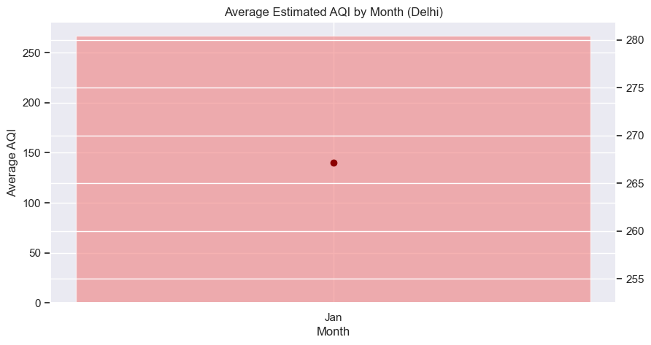
Interpretation: The visualization should be read together with the underlying numerical data and notebook calculations. It is included directly from the executed Jupyter Notebook output.

Output 2 – Distribution of Estimated AQI Values
The histogram shows the frequency distribution of the estimated AQI values. The KDE curve provides a smoothed view of the distribution and helps show where values are concentrated.
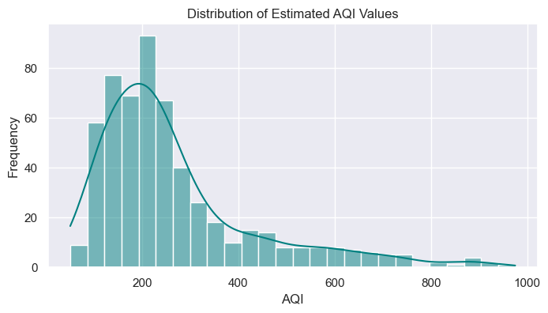
Interpretation: The visualization should be read together with the underlying numerical data and notebook calculations. It is included directly from the executed Jupyter Notebook output.

Output 3 – AQI Distribution by Day of Week
The box plot compares AQI values across weekdays. Each box summarizes the distribution for a day, helping identify differences in median, spread, and unusually high or low observations.
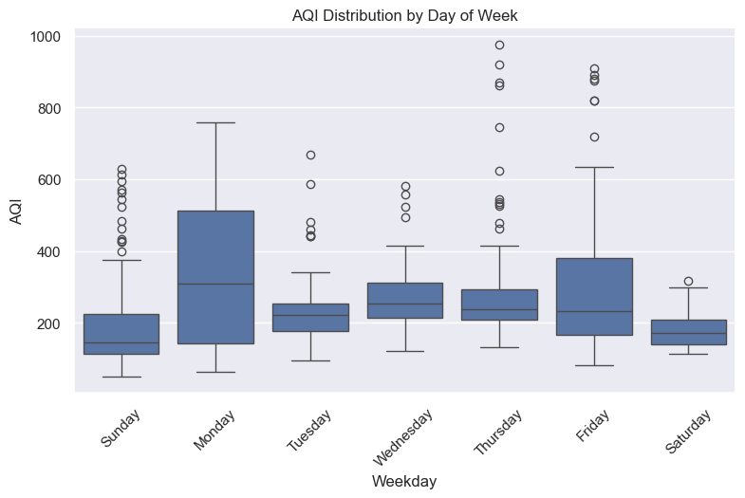
Interpretation: The visualization should be read together with the underlying numerical data and notebook calculations. It is included directly from the executed Jupyter Notebook output.

Output 4 – Correlation Matrix Between Pollutants and AQI
The heatmap displays pairwise correlation coefficients among AQI and the pollutant variables. Values closer to +1 indicate stronger positive association, while values closer to -1 indicate stronger negative association.
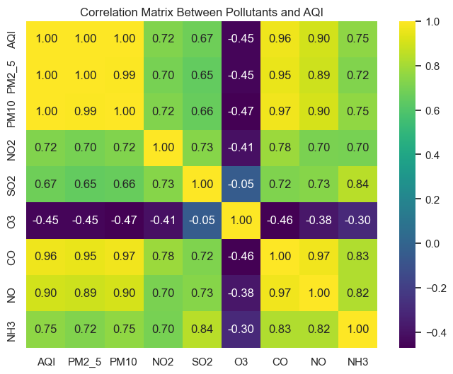
Interpretation: The visualization should be read together with the underlying numerical data and notebook calculations. It is included directly from the executed Jupyter Notebook output.

8. Key Observations
- The executed notebook reports an average estimated AQI of 267.18, with a maximum of 975.25 and a minimum of 50.81.
- The monthly grouping output identifies January as both the highest and lowest grouped month. This unusual result is retained exactly as produced by the notebook and should be reviewed in the code/data if a single distinct best and worst month is expected.
- The monthly visualization provides a direct comparison of estimated AQI across the calendar year.
- The AQI histogram provides an overall view of the spread and concentration of estimated AQI observations.
- The weekday box plot provides a distribution-based comparison rather than only comparing simple averages.
- The correlation heatmap provides a compact view of relationships between AQI and the measured pollutant variables.

9. README-Based Project Context
The submitted README states that the task is intended to build practical data-visualization skills and bridge basic concepts with real-world data analysis. It also specifies that the expected output should include cleaned/structured data, multiple plots showing trends, comparisons, and summaries, and clear observations after each visualization.

10. Conclusion
The Delhi AQI Analysis project demonstrates a complete intermediate data-analysis workflow: data import, preparation, calculated AQI creation, descriptive analysis, visualization, and interpretation. The notebook outputs provide several complementary views of air quality, including monthly variation, overall AQI distribution, weekday variation, and correlations among pollutants and AQI.
The project therefore provides practical experience in Python-based data analysis and data visualization while keeping the analysis reproducible in a Jupyter Notebook.

11. Project Files
- Jupyter Notebook: Shadowfox (Intermediate) (1).ipynb
- README: Readme (1)(1).md
- Dataset referenced by the notebook: delhiaqi.csv
- Generated analysis output: Delhi_AQI_Unique_Analysis.csv

12. Execution Summary
To reproduce the analysis, place the notebook and delhiaqi.csv in the expected project location, open the notebook in Jupyter, and run the cells in sequence. The outputs embedded in this report are the images stored in the submitted notebook, so the report can be reviewed even without re-running the notebook.

